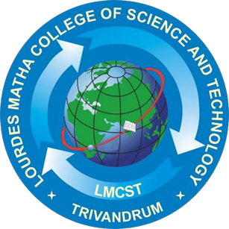

A PROJECT REPORT

Submitted by:

**LEKSHMI S R**

**LLMC17MCA020**

to

*The APJ Abdul Kalam Technological University*

*in partial fulfillment of the requirements for the award of the Degree*

*of*

*Master of Computer Applications*

**A SECURE IoT BASED MODERN HEALTHCARE SYSTEM USING BODY SENSOR NETWORK**

**Department of Computer Applications**

LOURDES MATHA COLLEGE OF SCIENCE AND TECHNOLOGY

KUTTICHAL, THIRUVANANTHAPURAM 695574

MAY 2020

**A SECURE IoT BASED MODERN HEALTHCARE SYSTEM USING BODY SENSOR NETWORK**

A PROJECT REPORT

Submitted by:

**LEKSHMI S R**

**LLMC17MCA020**

to

*The APJ Abdul Kalam Technological University*

*in partial fulfillment of the requirements for the award of the Degree*

*of*

*Master of Computer Applications*

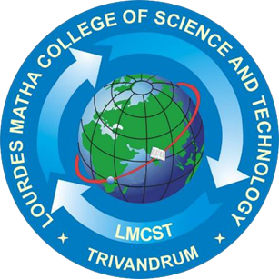

**Department of Computer Applications**

LOURDES MATHA COLLEGE OF SCIENCE AND TECHNOLOGY

KUTTICHAL, THIRUVANANTHAPURAM 695574

MAY 2020

**DEPARTMENT OF COMPUTER APPLICATIONS LOURDES MATHA COLLEGE OF SCIENCE AND TECHNOLOGY KUTTICHAL, THIRUVANANTHAPURAM**

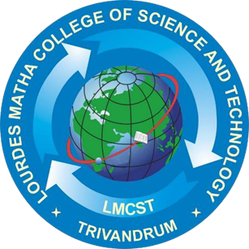

## CERTIFICATE

This is to certify that the report entitled **‘A SECURE IoT BASED MODERN HEALTHCARE SYSTEM USING BODY SENSOR NETWORK’** submitted by **LEKSHMI S R** to the APJ Abdul Kalam Technological University in partial fulfilment of the requirements for the award of the Degree of Master of Computer Applications is a Bonafede record of the project work carried out by him under my guidance and supervision.

Prof. Anjana J

(Internal Supervisor)

Prof. Justin G Russel Prof.Selma Joseph

(Project Co-ordinator) (Head of the Dept.)

## DECLARATION

I undersigned hereby declare that the project report ‘A Secure IoT Based Modern Healthcare System Using Body Sensor Network’, submitted for partial fulfilment of the requirements for the award of degree of Master of Computer Applications of the APJ Abdul Kalam Technological University, Kerala is a Bonafede work done by me under supervision of Prof. Anjana J. This submission represents my ideas in my own words and, I have adequately and accurately cited and referenced the original sources. I also declare that I have adhered to ethics of academic honesty and integrity and have not misrepresented or fabricated any data or idea or fact or source in my submission. I understand that any violation of the above will be a cause for disciplinary action by the institute and/or the University.

Place: Trivandrum Signature

Date: 14/06/2020Lekshmi S R